Personality Analyser based on Keyword Matching

Instruction manual to set up the software environment

# As the code was written and developed in EclipseIDE, it is recommended to use the same.

Minimum System requirements

1. Processor: Intel Core i5 4th Generation or AMD Athlon II X4 620
2. Memory: 8GB DDR3 or more
3. JDK 1.8 or latest installed
4. Stable internet connection with minimum speed of 1Mbps
5. HDD: Minimum 4GB available
6. OS: Linux 64-bit recommended

**Steps to run the program are as follows:**

###### Setting up the database

1. Download and install MySQL v5.6.39 Community Server 64-bit from the home website.
2. Download and install MySQL Workbench v6.2.5
3. Start the MySQL server on localhost by typing the commands on the console.
   1. For Linux: “service mysqld start”
   2. Windows: “<path/to/mysql_dir>/mysqld”
4. Open MySQL Workbench and Click on “+” symbol next to MySQL Connections.
   1. A new window will open to set up a new connection.

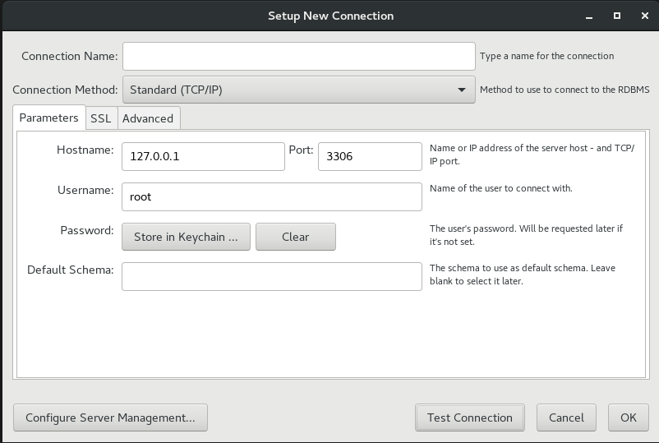

* 1. Enter a valid connection name, Username and click on ‘Test Connection’, if prompted to enter a password, then it must be entered.
  2. If the connection is successful, then click on ‘OK’. A new connection will be created.
  3. Click on the connection name.
  4. Once a new window has been opened, right-click the mouse within the ‘SCHEMAS’ section on the left side and select ‘Create Schema’.
  5. Enter the name for schema as “**PersonalityAnalyser**”, click on ‘Apply’, and ‘Apply’ again, and then click ‘Close’.
  6. Once the schema has been created, under ‘’Management’ section on top left side, click on ‘Data Import/Restore’

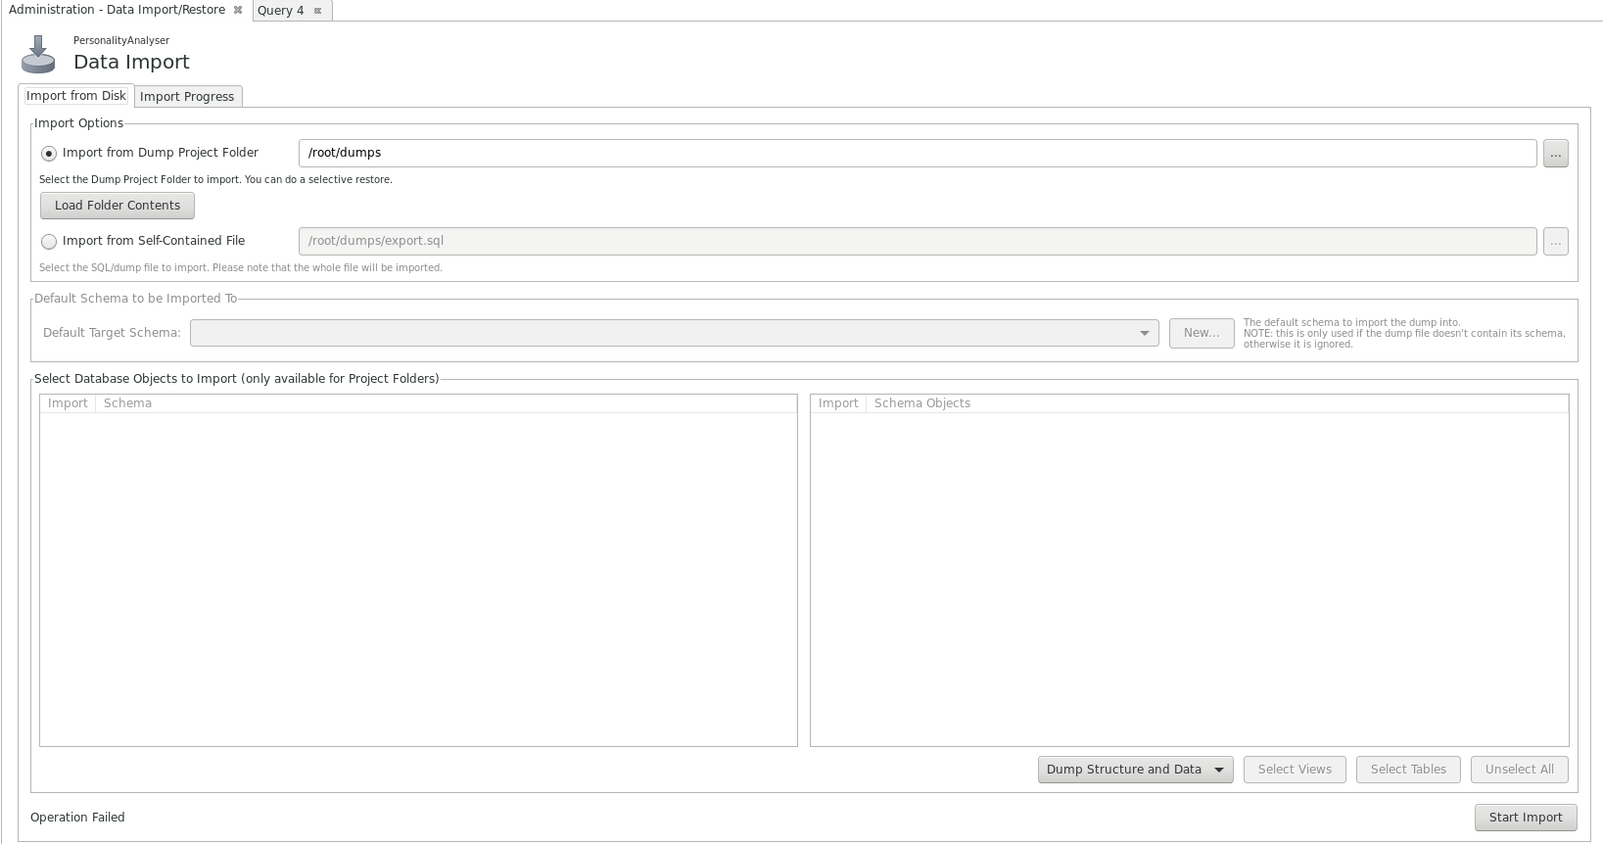

* 1. A new tab will be displayed as shown above. Now select ‘Import from Self-Contained File’ and click on the ‘…’ and select ‘PersonalityAnalyser.sql’ file containing all the tables and data.
  2. Once file has been selected, set the ‘Default Target Schema’ as ‘PersonalityAnalyser’ and select ‘Dump Structure and Data’ which can be found on the lower side of the tab.
  3. Make sure the selection looks like the screenshot attached below.

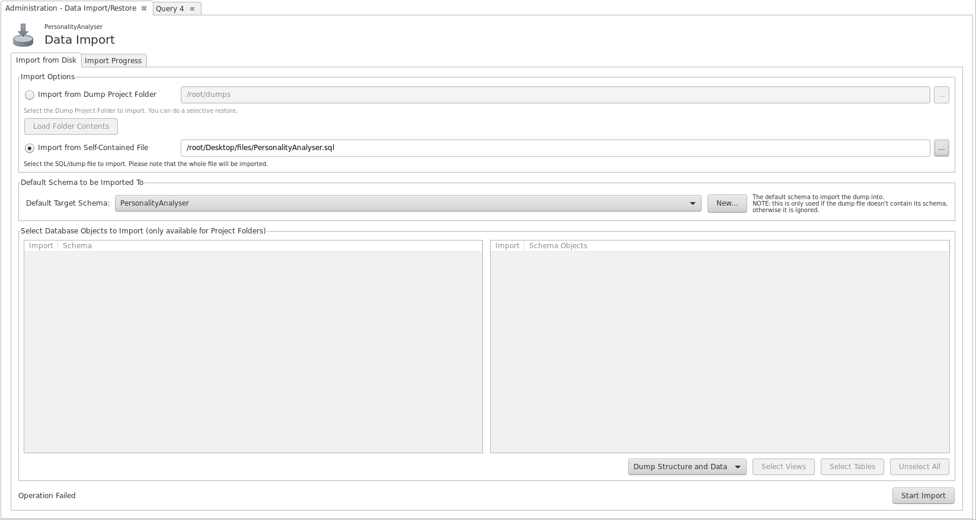

* 1. Click ‘Start Import’.
  2. Once the data import has been completed, go to Schemas, right-click on ‘PersonalityAnalyser’ and click ‘Refresh All’. The tables will be displayed as follows.

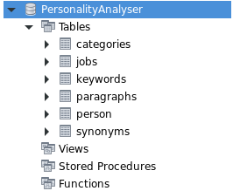

* 1. The database set up has been completed.

###### Set up the program environment

1. Download and Install EclipseIDE version ‘Oxygen’ and set up for Java Development environment
2. After the installation has been completed, run Eclipse.
3. Click on File->New->Java Project
4. Enter the project name, and select JavaSE-1.8 from the available JREs as the execution environment, and click ‘Finish’
5. A new project will be created on the workspace.
6. Using the System Explorer or the File Manager, navigate to the workspace on the hard disk where the project folder was created.
7. Open the project folder (It will be the one with the project name) and copy the entire contents of the ‘src’ directory from the submitted code, within the ‘src’ directory of this project folder.
8. **Directly within the project folder**, create a new directory named ‘**files**’ and copy files ‘english.jar’ and ‘synonym_table.csv’ within this directory.
9. Below attached are the exact directory structures.

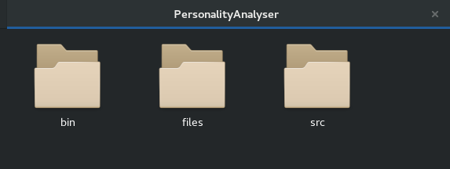

1. ‘PersonalityAnalyser’ is the project directory containing ‘files’, ‘src’ and ‘bin’ directories.

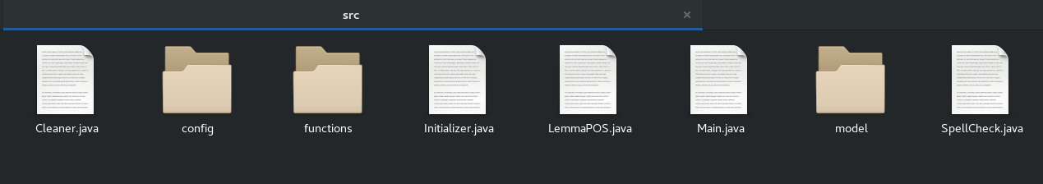

1. Shown above are the contents of the ‘src’ folder

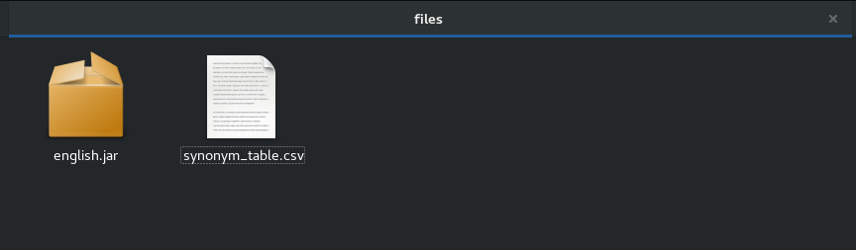

1. Shown above are the files within the ‘files’ directory
2. Switch to Eclipse, right-click on the project and select ‘Refresh’. This will populate the entire source code automatically.
3. Many errors will be detected by the Eclipse, because it is missing the required libraries.
4. To fix this, right-click on the project, go to ‘Build Path’, and select ‘Add External Archives’. Select all the archives shown in the screenshot below and click ‘OK’.

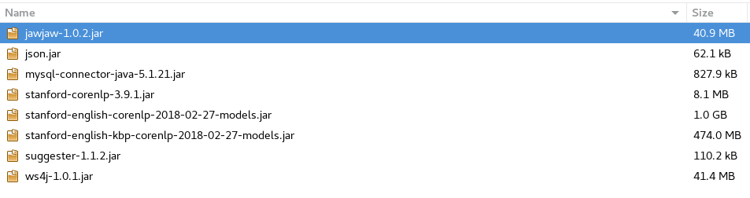

1. Now, there must be no errors detected.
2. Go to ‘src’->’config’->’DBConfig.java’ and open the file.

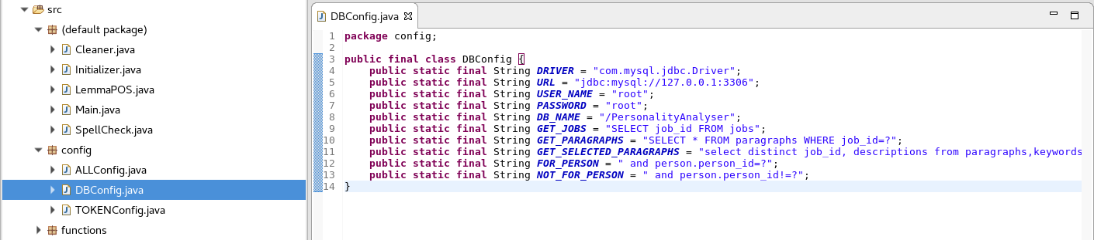

1. Enter the overwrite the USER_NAME and PASSWORD values with the credentials for the MySQL database.
2. The environment set up for the program has been completed.

###### Execute the program

1. Open the file called ‘Main.java’ and run the program. A screenshot has been attached below on how to run the program.

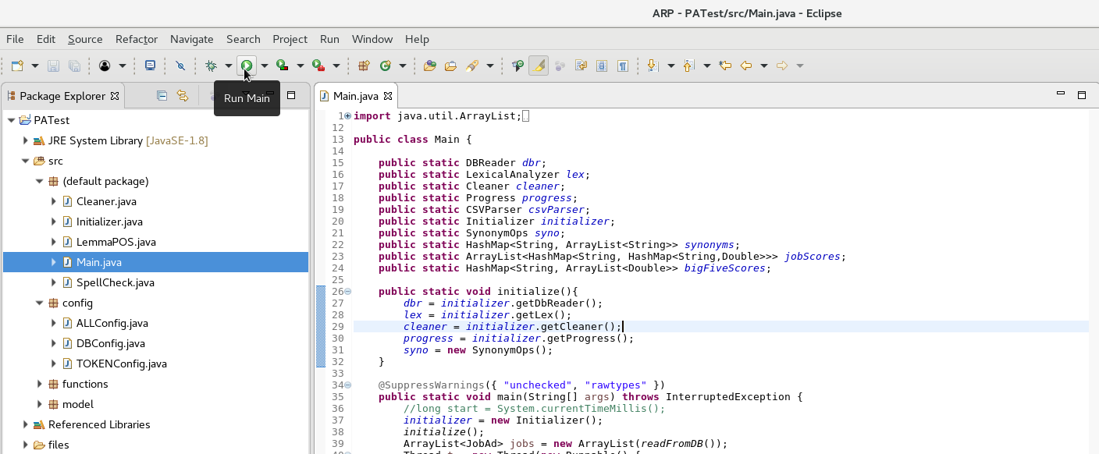

1. The button below the mouse pointer is used to run the program.
2. Below attached is a screenshot of program running in Eclipse console.

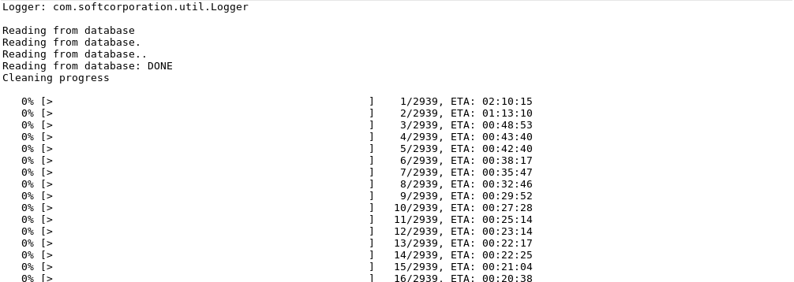

1. A progress bar will display the progress of execution of functions.
2. To view a demo execution, a limit can be set to the number of data read from the database. It can be set by modifying the values in ‘src’->’config’->’DBConfig.java’ and changing the values for the variables as displayed below.

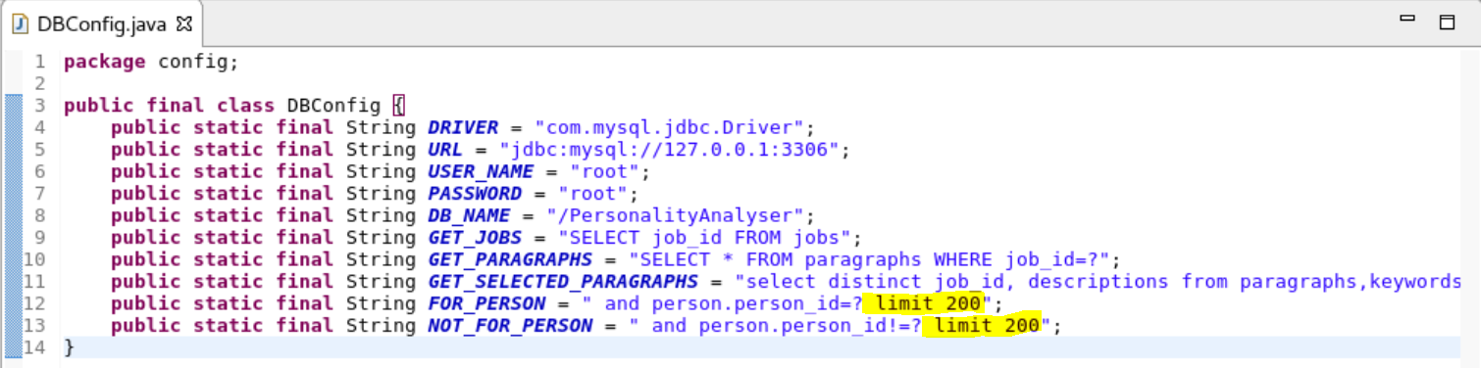

1. The highlighted section in the above image limits the maximum data read from database to 200.